9 Steps to a Socially Conscientious Enterprise
Give Your Business Heart That Lasts
Kurt Minson
You can call it conscious capitalism, social enterprise, social innovation and social entrepreneurism. It can also be known as a social impact company, a socially responsible or values driven business or as we, at AngelFAX, like to phrase it; a Socially Conscientious Enterprise (SCE). Regardless of the name, companies that embrace the improvement of society in a special way, while creating recognized value in the market place need to have great vision, a strong story and the drive to do things the right way. This drive and the emotional merit it generates is something that should matter to all companies as 2014 gets into full swing and St. Valentine's approaches.
According to Professor Archie B. Carroll, “Corporate Social Responsibility (CSR) involves the conduct of a business so that it is economically profitable, law abiding, ethical and socially supportive. To be socially responsible then means that profitability and obedience to the law are the most important conditions to consider when discussing a firm’s ethics and the extent to which it supports the society in which it exists with contributions of money, time and talent.”
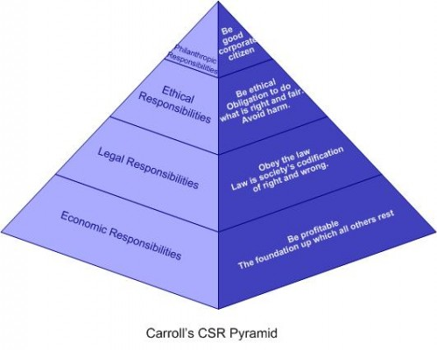
Carroll’s CSR model contains four levels of corporate responsibility, tiered from most to least important. According to Carroll, the “history of business suggests an early emphasis on the economic and then legal aspects and a later concern for the ethical and discretionary aspects”. Economic obligations are seen as being moderated by ethical responsibilities or social expectations and norms. Discretionary responsibilities go beyond these ethical responsibilities and include measures of philanthropic and social reinvestment.
AngelFAX flies with our SCE language and framework because we believe that the company's reinvestment in social elements is not discretionary. The five interlocking rings that define a Socially Conscientious Enterprise are as follows:
Passion for a social purpose or purposes that goes beyond profit
Engagement of customers and community through these purposes
Alignment of internal culture to support and advance the chosen purpose(s)
Engagement of organizational leadership with employees through the purposes
The conscious reinvestment of time, capital and human currency into social solutions.
This powerful combination highlights a SCE firm's awareness of the effects of its actions and attunes those actions to the market's social needs. More importantly, the quality of a SCE company compels it to move beyond the idea of simple responsibility; which is defined and judged by external standards, like laws. In contrast, the SCE leverages passion to build an inside motivation to meet social needs. This choice is made in an authentic, engaging way that is grounded in corporate social goals and designed to answer important questions about how we can improve the human condition. Nine steps that capture this process are listed below:
.
1) Ask the big question... WHY are you in business?
Of course we hope that your company has, is and will always continue to make money...hopefully BIG MONEY. But if the cash is your only reason for being in business, we suggest there is a funky disconnect between your ideal of material success and the need for socially significance outcomes. The WHY is more about the passionate outcomes you desire and the notions that customers and staff aren't expendable, that the communities you serve are important, that the environment has intrinsic value and that there is more to the idea of good corporate citizenship than naked profit, nice dividends and a great quarterly P and L.

2) Follow up with HOW your WHY will be shared with the world.
Once you have a firm hold on WHY, it's just natural that you ponder HOW that answer will be seen and communicated by and to your entire organization. Sure, you should have a great idea WHAT your business is about, but HOW is the bridge that links WHY you are in business to the WHAT your company delivers. And to be honest, the distinctiveness of your HOW is what captures the imagination of markets and drives sales.

3) Make your passion an important part of your purpose.
Invest time, effort, capital and social currency in something special, that lives and breathes at or near the heart of your business. This element must have a strong cultural connection to your staff and operations, but should be something valuable enough that you would do for free. For example, Patagonia's entire substance revolves around outdoor sports, like climbing, surfing and hiking. By direct association, the Patagonia mission also includes the continuous protection of the natural environment, where all this cool stuff takes place. This kind of passion fuels both social results and outstanding profits when it is real, culturally supported and balanced.

4) Ask and answer how your company improves quality of life in your community.
The community is the land, people, vision and institutions that live and breathe around your business. How your company delivers great products/services and supports clean air/water, work life balance, good education, employee fulfillment, charitable giving or other outcome must be at or near the top of any SCE's priority list, along with improving revenues and profits.
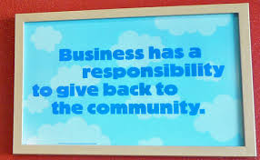

5) Look inside your company and share your passion and SCE purpose with your employees to embrace, contribute suggestions to and guide your efforts in ways that are meaningful and fun.
The gap between ownership/management and staff employees can be measured in light years in some organizations. When it comes to social conscientiousness though, putting everyone on the same page and making staff real partners in any initiatives is crucial to success. Top down directives never have the same long term attraction and energy as concepts where line personnel are included and their opinions valued. These platforms also have the potential to build a sweet spot of common ground between managers and hourly folks; an extra special benefit in and of itself.

6) Consider outcome goals for your firm that reach beyond revenues and profits
It is vital that every business track, trend and budget their revenue, expenses and profitability. For an SCE, however, tracking specific results tied to their passion/purpose outcome is just as important. These outcomes can be tied to dollars raised and reinvested in your chosen cause, the measured reduction of carbon footprint, the support of a certain number of disabled veterans or the contribution of a specific number of volunteer hours to a passionate purpose. By scheduling the cause goal, a higher level of accountability and therefore success is likely.

7) Establish a worthwhile dialogue with customers
Any company worth a redeemed soda bottle must maintain meaningful conversations with its markets and customers. Socially Conscientious Enterprises take that engagement to the next level by making their interactions as much about how the business supports a deeply important cause as the newest products and services coming down the line. This dual focus is not intended just to drive sales, but as a sincere extension of the business values that SCE's hold. The connections between company values and market values enhances the client relationship and that bond is the path to greater growth, profitability and long term social significance.

8) Develop an ongoing conversation of engagement with a wide range of community stakeholders. to engage and follow your lead in their own ways
SCE success is as much a question of how far your impact reaches as it is one of execution. The sharing of vital knowledge, leveraging management as social mentors, showing the C suite as engaged exemplars of your cause and employees as idea generators all play a part in the process of connecting with community. Social outcomes that your service community values too, must be heavily considered as a central focus of any performance metric that is adopted and tracked.

9) Be a distinguished corporate actor by establishing your own foundation or adopting a hybrid legal form that puts your social ideas securely into practice
This is not a free proposition, but the creation of a company foundation or adoption of one of the new organizational forms—such as a low profit limited liability corporation (L3C), benefit corporation, or flexible purpose corporation can set the table for you to connect with your service community in substantial ways that amp up your impact and extend beyond the ledger.

